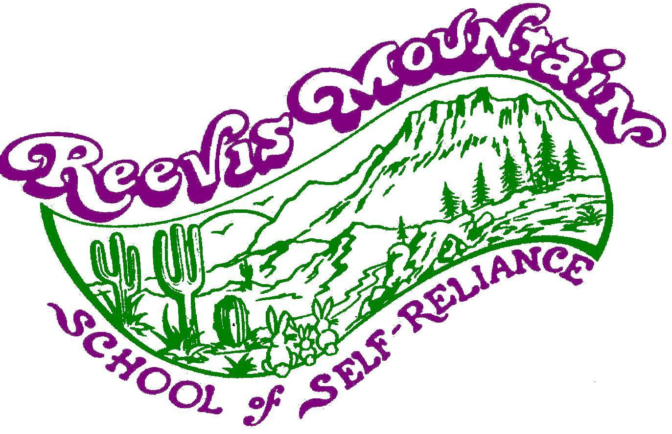
Sep 2026

Application for Work-Exchange Internship

Dear Person,
Thank you for inquiring about internship opportunities at Reevis Mountain School!
We welcome a few people to come work on the farm in exchange for living quarters and meals, for whatever period of time is enriching for both you and us. Although we don’t require a commitment on either side, we prefer that you be able to stay at least three months. It takes about a month to learn the ropes and become comfortable working independently, and it gets more fun for everyone as you learn your way around, become part of the community, and are able to take on more responsibility.

If you have not already looked at our website, please do (www.reevismountain.org). It will give you a good idea of who we are. Reevis is not just an organic farm or a school for self-reliance skills—it’s a place of inspiration and peace, providing us the space to grow in health, wisdom, and joy. Reevis’s magic has had a profoundly positive effect on the lives of many people who have spent time here.

We look forward to learning more about you!
- Bigfoot and the Reevis crew
Things you should know about Reevis Mountain School …
- Reevis Mountain School of Self-Reliance is a wilderness farmstead, spiritual retreat, and school for skills and attitudes that enhance self-reliance. Reevis provides a place of inspiration, peace, and reverence for nature, where, in a magical remote wilderness setting, students and interns can learn natural healing and self-reliance skills, experience growing their own food, develop spiritual awareness that is not tied to any particular religion, enjoy a spirit of community, and live healthfully.
- Reevis is headed by Peter “Bigfoot,” who founded RMS in 1979, then as a “new age” community. Bigfoot is best known for his 1976 summer solo trek across the Sonoran Desert, when he trekked 85 miles in 15 days, bringing no food or water and foraging for his needs. He is a respected natural healer and Southwestern herbologist.
- Our human population usually varies from two to seven.
- We teach and promote self-reliance through (1) offering classes and lectures on wilderness survival, natural healing, meditation, and farmstead living skills; (2) providing an example of a working off-the-grid farmstead; (3) growing healthy organic food for our customers and ourselves; (4) producing and selling herbal remedies formulated by Peter Bigfoot, and (5) offering work-exchange internships.
- There is no typical day at Reevis. From day to day we do whatever is needed to live healthy and happy in the wilderness, close to the source. This includes maintaining the farm, growing our food, caring for our health, and learning and growing in nature awareness, self-awareness, and our ability to live peacefully and joyfully together. Every day there is more to learn.
- We encourage meditation for spiritual health and awareness. After meals we often meditate and read from books about natural healing, metaphysics and human potential. Taking part in these readings is an enriching part of our social life.
- We practice natural healing using herbs and acupressure (Jin Shin Jyutsu). Bigfoot is an experienced healer, but he is not a medical doctor. The nearest hospital is an hour’s drive away over rough country roads, and we cannot guarantee that a vehicle or a driver will be available to take you to a hospital, clinic, or doctor’s office. We provide free natural healing for illnesses and injuries that you experience while at Reevis … if you prefer to go to a medical doctor, clinic, or hospital, you will be responsible for the costs.
- Reevis is located within the Superstition Wilderness of eastern Arizona, south of the town of Roosevelt. Our nearest neighbor is six miles away, and the nearest “conveniences” are ten miles away. The road into our location requires a 4WD at the best of times and is occasionally flooded or damaged so that we cannot leave or return to the farm for a period of hours, days, or sometimes longer. Please email us for road conditions before you make plans to drive in.
- Interns usually sleep in small private cabins. These spaces are cozy, have beds, small furniture, and either a wood stove or a propane heater. You will be responsible for the cleanliness of your own sleeping quarters. Be aware that the living quarters are mostly spider-, scorpion-, and rodent-proof, but not completely. Sleeping quarters have no electricity or running water. We spend most of our awake time outdoors or in the common house.
- You should bring your own sleeping bag, work gloves, and headlamp or flashlight. If your headlamp or flashlight is not rechargeable, please bring extra batteries or a charger for your rechargeable batteries.
- The common house includes a well-equipped kitchen, living room, porch/workroom, library, office (for RMS business), and healing room. The house has electricity and running water. Our stone showerhouse provides solar and wood-heated hot water year round. The farm does not have flush toilets—friendly outhouses are located conveniently around the property. We are blessed to have a year-round creek and two wells.
- We have Starlink internet available for interns at the house, but there is no reliable cellphone service due to the mountainous terrain. Our satellite internet service is primarily for official Reevis business. At appropriate times, interns are able to check email and manage personal accounts. We are happy to take letters to the post office for you when we go into town, which is usually once or twice per week.
- We serve two meals per day (breakfast and supper), and interns are welcome to prepare their own snack lunch. Our daily diet consists of vegetables (raw and cooked), fruit, meat and fish. Whole grains, olive/coconut oil, dairy in limited amounts, spices, and sea salt are available.. Bigfoot is a believer that meat is an important part of the diet for most people. We also encourage healthful food combining to aid digestion. Access to sugary foods is limited, and, with a few exceptions, no commercially processed foods are available. If your preferred diet is heavy on nuts and seeds, please bring your own supplies.
- Interns will learn to prepare the Reevis diet, usually cooking in turns. No previous cooking experience is necessary. All personal food must be stored in the kitchen or food storage areas. Private “stashes” of food are not allowed in living quarters because of issues with insects, rodents, and larger wildlife including bears.
- Alcohol, smoking, marijuana, illegal drugs (use or possession), tobacco, firearms, fireworks, and pets are prohibited. We discourage junk food and the over-use of electronics at Reevis. The playing of music on electronic devices is limited to the use of personal music players with earphones so that the sound is not audible to others. We treasure the serenity of nature. And much as we love dogs, Reevis is not a good place for them.
- All of us who live at Reevis strive to abide by the Integrity Agreement that follows this application. You will be asked to sign and abide by it as well.
- We are looking for people who have an attitude of assistance, appreciation, and respect. If you would bring an attitude of resistance, resentment, or disrespect, please do not apply.
- Internships are on a pure work exchange basis; RMS provides living quarters and meals in exchange for a full day’s work. No monetary pay is available. Occasional exceptions may be made for dependable and skilled interns who stay at Reevis for an extended time. Interns are free to come and go as they please (with their own transportation), although we ask that they be considerate and honor any agreements about work to be done, etc.
- Interns are welcome to stay as long as the situation is mutually enriching for all concerned. There is no commitment on either side. Please have in mind a place to go and a way to get there in case you find that you desire or are asked to leave before your expected stay is up.
- Once your application has been accepted, we ask for a $50 deposit to hold your spot, which will be returned to you after you have been here one month. We do this to reduce the number of people who do not arrive as planned, leaving us short handed.
- For more information about Reevis Mountain School, and pictures, please visit our website: www.reevismountain.org.

Application for Work-Exchange Internship
Name: ____________________________________________________________

Mailing address: ____________________________________________________________

Phone: ____________________________________________________________

Email: ____________________________________________________________

Dear Person,

We are asking the following questions in order to help us predict whether an internship at Reevis Mountain School would be mutually enriching for you and for us. By giving full and candid answers, you can help us get an accurate feeling for how you would fit into Reevis, how you could contribute, and what the challenges and benefits might be for you. Feel free to give more information than is asked for.

You can submit this application, beginning with this page, by email (info@reevismountain.org) or regular mail (RMS, 7448 S. J–B Ranch Rd., Roosevelt, AZ 85545). If you are coming with another person, please fill out individual forms – there is a spot in the application to let us know who you are travelling with.

For the yes/no questions, please either circle yes or no, or delete the one that does not apply.

Thank you!

Date of birth: _________________________________

Hometown (where you consider home): __________________________________________

Are you dependent on smoking, alcohol, marijuana, tobacco, or illegal drugs? Yes No
If “yes,” this program is not for you—we do not allow smoking, alcohol, marijuana, tobacco, illegal drugs (use or possession) at RMS. Please do not apply. This is not a rehabilitation facility.

How did you hear about us? ___________________________________________________

Have you been to Reevis before? If so, when? _______________________________________

Why would you like to come to Reevis?
____________________________________________________________________________

____________________________________________________________________________

____________________________________________________________________________

____________________________________________________________________________

____________________________________________________________________________

____________________________________________________________________________
(feel free to add more pages or write on the back of the sheet)

When would you like to come? _________________________________________________

How long do you envision staying with us? ________________________________________

Are you planning to come with another person? Yes No

If yes, please give their name(s): ____________________________________________

Will you be bringing a car? Yes No
If yes, does your vehicle have 4-wheel drive? Yes No
If the vehicle is not 4x4, do not attempt to drive past our neighbor’s ranch. Our neighbor has been kind enough to allow our visitors to leave their vehicles on his property. Be respectful, and you may leave your vehicle there and walk the 6 mile forest road. Allow yourself 3 hours and plan to arrive here between 9am and 4pm. Bring water but pack light. We will be able to drive you back down to the ranch to get your gear at our convenience, usually later that same day.

Will you need to come and go from RMS during the time of your internship? Yes No
If yes, please describe: ___________________________________________________

What is your preferred daily diet? (Please include number and times of meals and types of food, including any dietary restrictions or allergies.)

______________________________________________________________________________

______________________________________________________________________________

______________________________________________________________________________

______________________________________________________________________________

Do you have any illness or condition(s) that would interfere with doing the physical work described in this application? Yes No

If yes, please describe how it could interfere with doing the physical work:
_______________________________________________________________________

________________________________________________________________________

What medications do you anticipate taking while at RMS, if any?

_____________________________________________________________________________

Are you able to lift 50 pounds and carry it 20 feet? Yes No

Are you able to hike six miles without taking more than a ten-minute break? Yes No

Do you tend to be accident-prone? Yes No
absent-minded? Yes No

Do you have a greater than average fear of spiders? Yes No
snakes? Yes No
scorpions? Yes No
insects? Yes No
rodents? Yes No
wild animals? Yes No
the dark? Yes No
heights? Yes No

What level of formal education have you completed? ______________________________

What line(s) of work have you been doing in the past few years?

_____________________________________________________________________________

_____________________________________________________________________________

Do you have previous experience living in a communal situation? Yes No

If yes, please describe: ____________________________________________________

______________________________________________________________________________

Suppose the following are two extremes in attitudes about the way people should behave: one is that there should be rules and people should always adhere to them consistently … the other is that there should be no rules and people should do what is right in the context of the moment. Where on the continuum between those extremes would your attitude fall? (Feel free to explain or qualify.)

______________________________________________________________________________

______________________________________________________________________________

Please name two things that make you angry:

1) ___________________________________________________________________________

2) ___________________________________________________________________________

And two things that make you happy:

1) ___________________________________________________________________________

2) ___________________________________________________________________________

What’s your favorite thing to do?

_____________________________________________________________________________

We are blessed to live in a very special place—eight miles inside the Tonto National Forest on an inholding (land surrounded on all sides by National Forest) that was homesteaded in the 1920s. And we live here very comfortably, with electricity, water to drink, home grown food, freedom from most EMFs and pollutants, deer and other wildlife for neighbors, and a starry night sky.

The things we do every day are the things we have to do in order to continue to live here. That means: growing our garden; caring for our orchard, vineyard, and animals; maintaining the buildings, tools, and infrastructure; growing and harvesting herbs for our herbal remedies business; gathering firewood; holding classes (spring and fall), and so on.

In order to live here, we do need to earn money. Although we grow a lot of our own food, we purchase things like grains, oils, spices, and paper goods. Our largest expenses are propane and the costs of running our vehicles. To earn money, we have three streams of income: our herbal remedies business, classes that we teach in the spring and fall, and produce sales in season.

We receive no government grants or funds, and although we are a nonprofit educational organization (501c3), donations cover less than 10 percent of our operating expenses—so, financially, we are primarily self-supporting. Interns are often involved in our money-making enterprises by harvesting and processing herbs, helping during classes (they are also encouraged to attend the classes as long as chores get done), and helping grow the produce that we sell.

As you might imagine, all of this keeps us busy. But we do find time for other activities, things we just enjoy doing and learning. Interns hike, play music, learn to make sourdough bread or tan hides, and so on. We also spend time at the table as a family, reading aloud and talking after meals.

Here’s a list of things that could and often do happen on a normal day at Reevis:

weeding the garden (which could mean digging out bermuda grass or bindweed)
thinning seedlings
hand-watering young plants twice a day
harvesting and processing herbs
wheeling 50 barrows of composted manure into the garden
irrigating the orchard
clearing brush around the property
moving 50-pound sacks of poultry feed from one place to another
shoveling a truckload of sand for road maintenance
digging up and hand-grinding burdock root
chopping firewood
giving natural healing treatments to a person who’s been injured or got sick
tilling a bed in the garden
capturing a rattlesnake and taking it away down the road
entertaining a group of visitors
preparing meals
cleaning the dishes and kitchen after meals
pruning trees in the orchard
harvesting seeds from the garden
hiking up the creek to harvest wild plants
digging up part of an irrigation pipe to fix a leak
planting a new tree in the orchard
repairing tree basins in the orchard
mopping the kitchen floor
fixing a mechanical problem with the tiller
replacing a pane of glass in the greenhouse
mending a screen in a cabin
building a new shed
cleaning and tidying the farm prior to a class or visitor group
processing a chicken for supper
tending to a turkey that’s been stung by a scorpion
taking apart the kitchen drain pipes to unclog them
going out in a rainstorm to dig drainage control ditches
scrubbing out the irrigation tank

These are the kinds of things we spend most of our time doing, and we enjoy it all, almost all the time—that’s why we’re here and not living somewhere else doing something else. We’re looking for people who would enjoy these things, too. So, considering that you would be doing a variety of activities each day, and some days are longer or shorter than others, would you please tell us how many hours per day or per week you would enjoy being engaged in these activities? _________________

Also, sometimes things come up … for example, a rainy day turns into a deluge in the evening, and we have to put on our rain gear and dig ditches so structures don’t flood … or we have to get a planting bed ready and planted on a particular day … or someone gets sick and others have to pitch in a little more. Would you be willing to work a little longer on some occasions, when necessary? ___________

Please be honest with these responses. If you would not enjoy doing the things we do here to the extent we do them, then you would not be happy here. In fact, the best case is when the person doesn’t even consider these activities to be work. This is just the way we live. Bigfoot’s motto is Live What You Love! If you wouldn’t love being here and doing what we do, please don’t apply.

For the table below, please place a mark in the appropriate column(s). Feel free to give more information on a separate page or the back of this sheet.

Activity | I have skills or experience relevant to this activity | I am interested in doing or learning this activity | I am unable or unwilling to do this activity
Weeding
Planting
Tilling/garden bed preparation
Harvesting
Cooking
Food preservation
Housekeeping
Sewing, mending
Firewood gathering/splitting
Carpentry
Stone masonry
Electrical
Solar (PV or water systems)
Wind power
Road maintenance
Auto repair
Small engine repair/ maintenance
Irrigation
Livestock husbandry
Slaughtering & processing livestock
Orchard care
Vineyard care
Natural healing
First aid
Herb harvesting & processing
Bookkeeping skills

Computer skills

Please describe your gardening/farming experience and interests. ____________________

_____________________________________________________________________________

_____________________________________________________________________________

_____________________________________________________________________________

_____________________________________________________________________________

_____________________________________________________________________________

_____________________________________________________________________________

What is your favorite book? ____________________________________________________

Do your decisions tend to be based more on what is good for the group or what is in your own individual best interest?

______________________________________________________________________________

How do you respond to instruction and criticism?

_____________________________________________________________________________

_____________________________________________________________________________

Do you speak English fluently? Yes No

Do you meditate? If so, we’d be interested in knowing a little about your practice.

_____________________________________________________________________________

____________________________________________________________________________

In what ways could you contribute to life at Reevis? We’re interested in how you could contribute both to daily work and to the harmony and emotional tone of our farmstead.

______________________________________________________________________________

______________________________________________________________________________

______________________________________________________________________________

______________________________________________________________________________

______________________________________________________________________________

______________________________________________________________________________

______________________________________________________________________________

What do you hope to gain for yourself by being at Reevis?

______________________________________________________________________________

______________________________________________________________________________

______________________________________________________________________________

What do you anticipate being the challenges for you of living and working at Reevis?

______________________________________________________________________________

______________________________________________________________________________

______________________________________________________________________________

Please send a current picture of yourself. We do not consider race, gender, or age, but it is important for us to see who we are communicating with. It’s not a beauty contest! Please email it or attach it to this form.

Please sign below to indicate that the information you have provided on this application is correct to the best of your knowledge, and that you have read and understand the information about Reevis Mountain School given above.

_______________________________________________
(Name)

_______________________________________________
(Date)

Reevis Mountain School
Integrity Agreement

1) If I have an emotionally charged grievance, I will write it down on paper to organize
my thoughts so my points will be direct, honest, and easily understood.

2) I will keep in mind that we are all on the same team here. I agree to look for solutions,
not problems.

3) I will not deliver my grievance as an attack, but rather as an effort to gain
understanding and a better line of communication, attempting to see it from the
other’s point of view.

4) I pledge myself to be a love giver, not a fault finder. I will strive to be aware of my
intent and speak only truth as I understand it to be.

5) I will be ready to expand my truth when a better idea presents itself.

6) If I am presented with a grievance, I will respectfully listen to what is being said.

7) I will not defend myself. I will consider what is being said as a suggestion for
improvement.

8) I will explain, but not defend, my position. I will be honest, I will not blame, I will not
argue. I will seek understanding and solutions.

9) I understand that honesty solves most problems and anything less creates them.

10) I will not do something I permanently regret because I am temporarily upset.

11) I, ____________________________, have read the above guidelines and
promise to do my very best to practice these guidelines in my daily life.

_____________________________________
Signature
______________________________________
Date

Release and Hold Harmless Waiver of Liability Agreement
The purpose of this waiver is to release us from carrying some very expensive liability insurance; an additional expense that would raise the cost of our events out of reach for most of our participants. So we invite you to exercise personal responsibility for yourself and your belongings and agree not to sue us for anything.

We will do our very best to provide you with an awesomely great and safe learning
experience. If you have any problem while participating in any of our events please tell us so that we can assist you.

Photo Release ….. Photos may be used in some of our brochures or catalogues, etc. If you do not want your picture taken just say so, or step away from the camera or cover your face.

I, ___________________________ am aware that such wild outdoor (and maybe indoors too) activities and experiences may involve some hazards. I voluntarily promise not to sue Reevis Mountain School or EEEE Corp (our land owner) or any of our affiliates. I do agree to waive my right to sue. I voluntarily assume full responsibility for my own well being and my belongings. Any child under the age of 18 is the full responsibility of their parent and/or legal guardian.

__________________________________________ _____________________
Signature Date

__________________________________________ _________________________
Signature of Parent or Guardian if under 18 yrs of age Date

